^{Hillcrest Happenings}
PEN Update October 9th
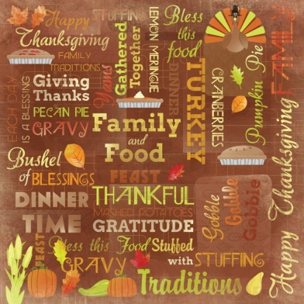
Happy Thanksgiving to all our Hillcrest Families
Please take this weekend to rest and relax with family and friends. Be safe and enjoy all the wonderful blessings of Thanksgiving. There is no school on Monday.
Tuesday, October 13th is a Day 1

Cross Country Meet update
Congratulations to everyone who participated in the Cross Country Meet this Thursday. Hillcrest was well represented and demonstrated excellent sportsmanship.
Thank you to all the coaches, parents and athletes for your commitment and support of the Cross Country Team. Good luck to all the participants that have moved on to the Regional Meet.

Slo-Pitch
Congratulations to the Girls and Boys Slo-Pitch Teams who participated in their tournaments this week. The Boys have moved onto the playoffs. Thank you to the athletes, parents and coaches for their support.

Clothing Drive is coming soon
We will be accepting gently used clothing including: children's and adult sized coats, snow pants, toques, scarves, as well as tops and pants/skirts, and CLEAN winter boots in excellent condition only.
Clothing MUST be LAUNDERED before being donated and bags labelled with donors name. Volunteers will not be washing donations this year (we did 14 loads of wash last year). The clothing is a gift to another family.
Stay Tuned for more information…

Thanksgiving is on Monday, October 12th. There is no school that day.

